|  |  |  |
| --- | --- | --- |
|  |  |  |

Symphony Limited

User Guide – Semester III

|  |  |  |  |
| --- | --- | --- | --- |
| **Guide Teacher:** | Phan Minh Tâm | | |
| **Batch:** | GC0862 | | |
| **Group:** | 1 | | |
| **Group Members :** | FullName | | Student No |
|  | 1. | Võ Minh Nhựt | GC60222 |
|  | 2. | Trần Nguyễn Công Nguyên | GC60263 |
|  | 3. | Nguyễn Ngọc Kiều Trinh | GC60229 |
|  | 4. | Đỗ Ngọc Quý | GC60257 |
|  |  |  |  |

**<11-2013>**

1. **User Guide(Guest-Role)**

**1. GET COURSES INFO**

**-**To get available courses, search for it from **search course** box or simply click to **course** button on the top menu. 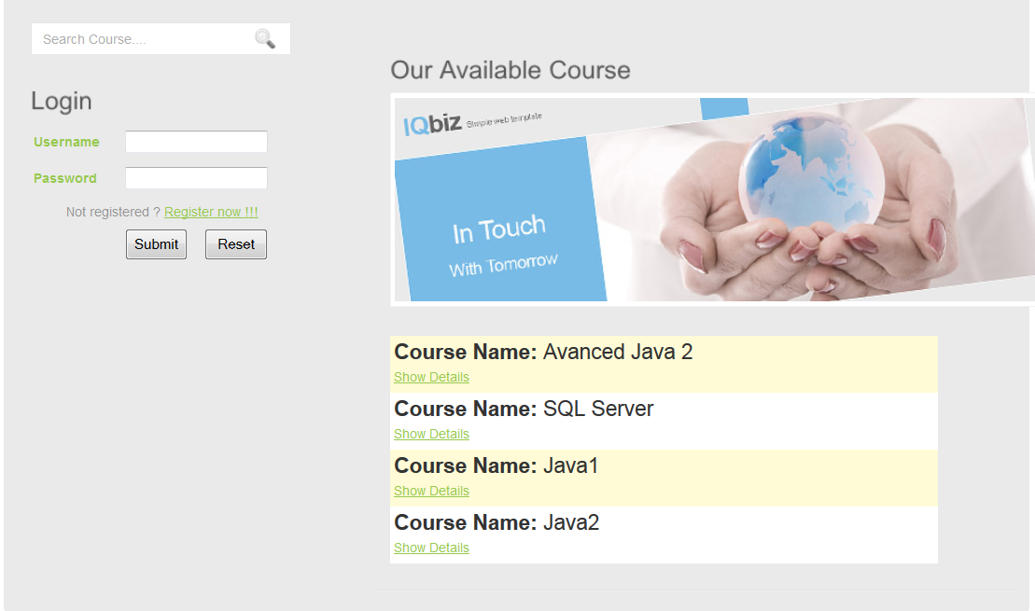

-To get Course Details click on **Show details** link under each course listed. 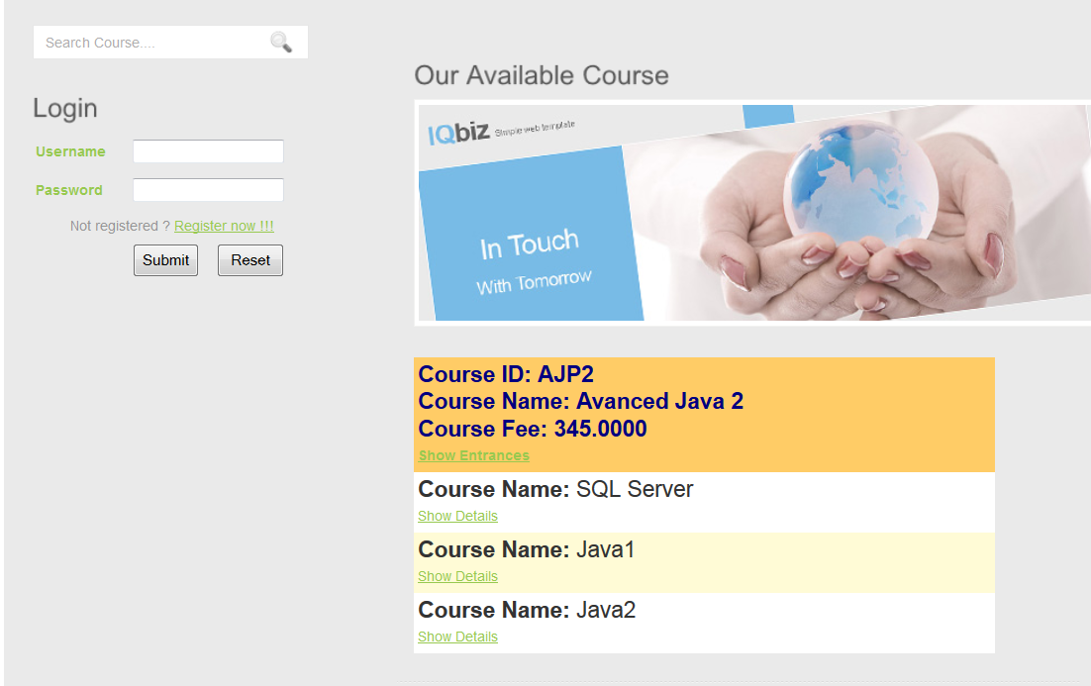

-To get available entrances, click on **Show Entrances** link under selected course.

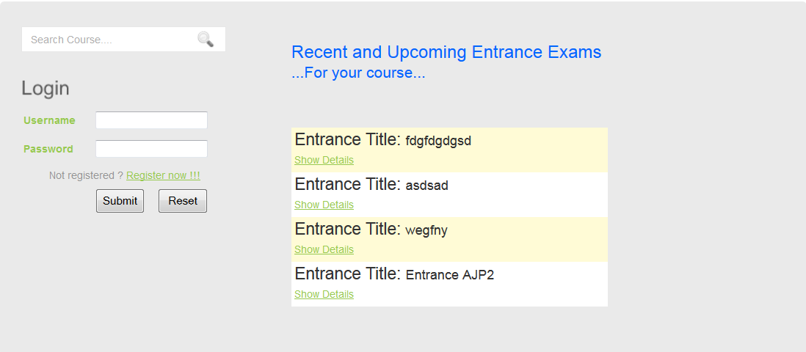

-To get Entrance Details. Click on **Show Details** link under each Entrance listed.

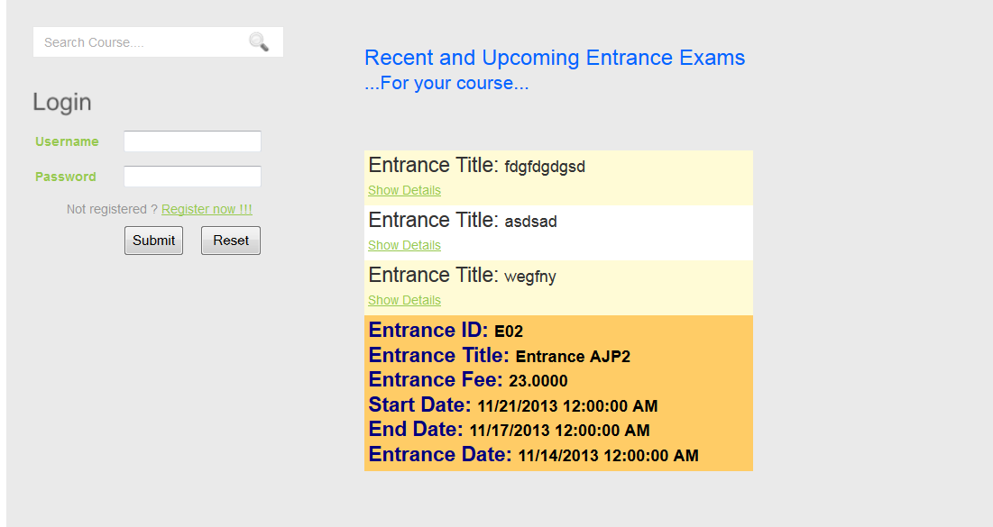

**2. FEEDBACK**

**-**To make a feedback you can click on **FeedBack** button on the top menu.

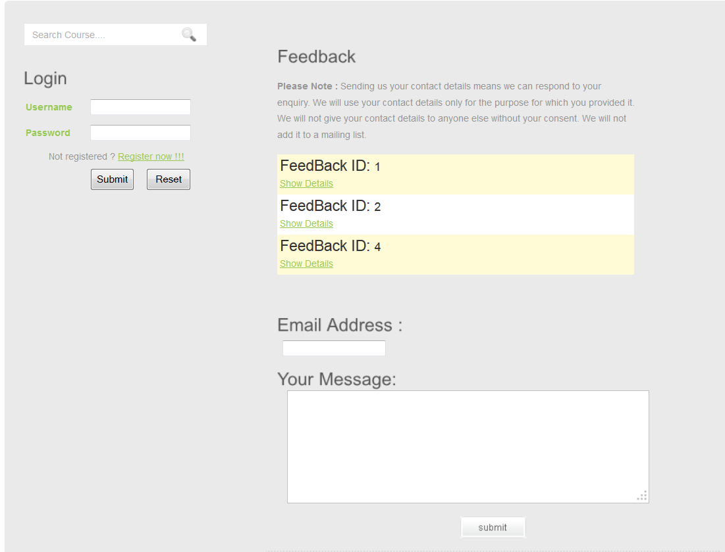

-To view a top recent answered feedback you can click on **Show Details** link

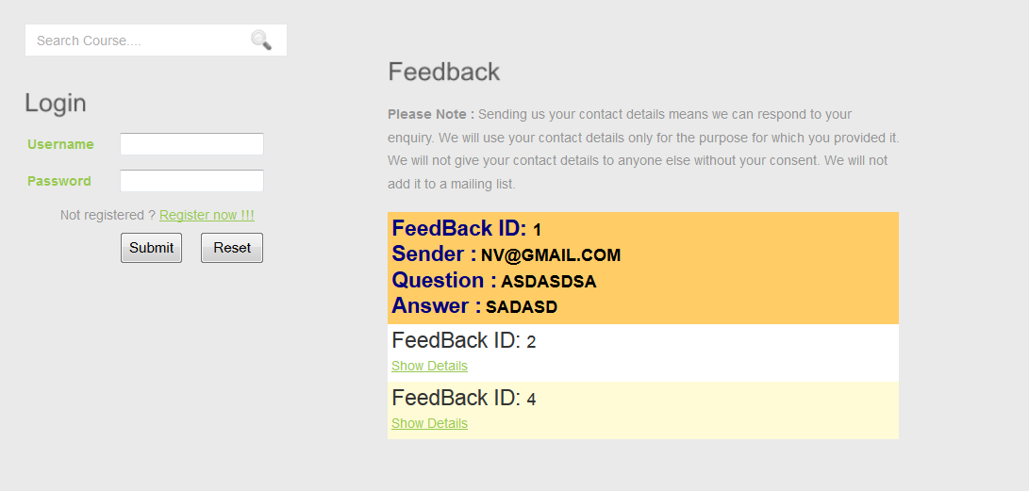

-To make a feedback just simply enter your mail and question in appropriate boxes.

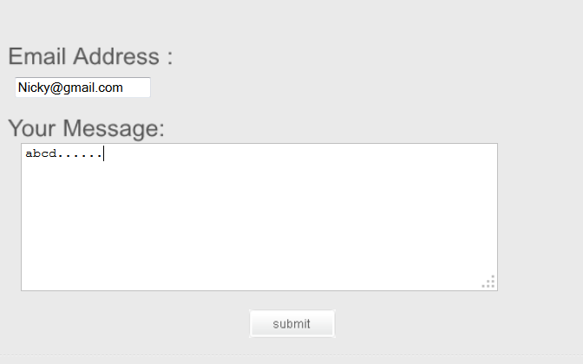

-Click on **Submit** button

1. **User Guide(User –Role)**

**1. USER REGISTRATION**

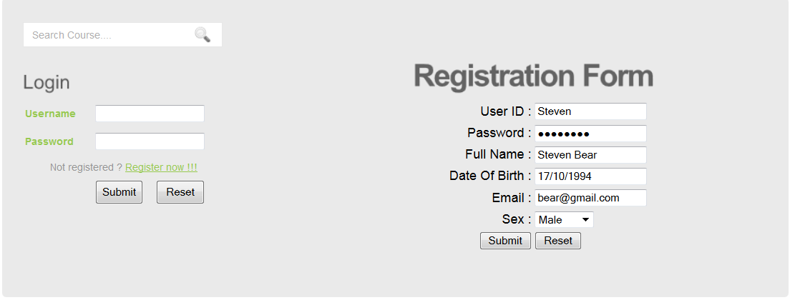

**-**To register a new user, Click on **Register now!!!** Link then input the information as guided.

-Click Submit to submit information or reset to reset form.

**2. EXAMINATION REGISTRATION**

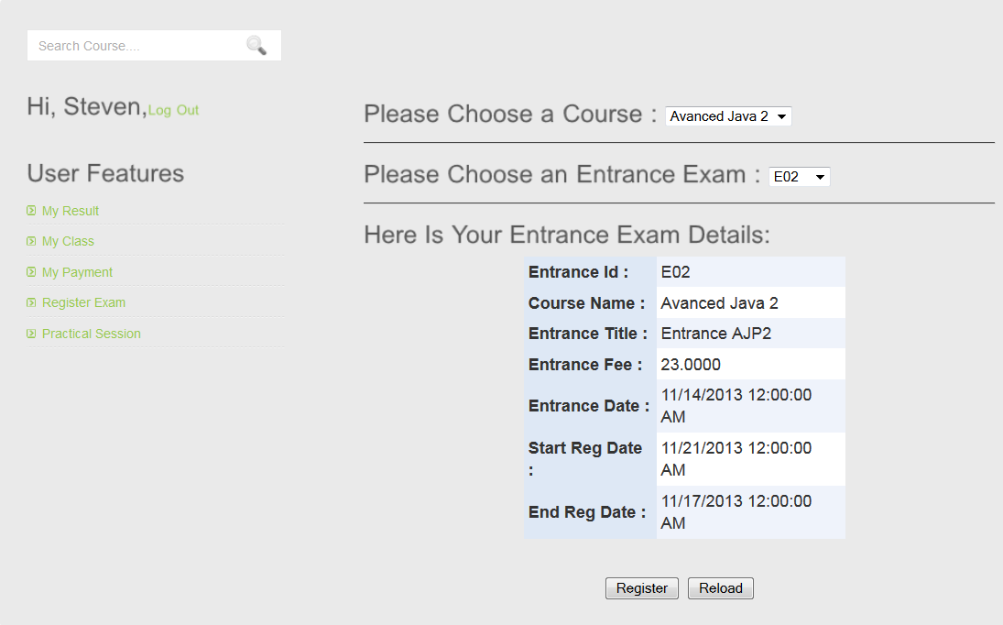

**-**To register an exam, user must logged as user then click on link **Register Exam** .Then choose a course from a combo box. If that course has an available entrance, it’ll be shown in the next combo box.

-To accept a registration. Click on Register.

**3. PAY A PAYMENT**

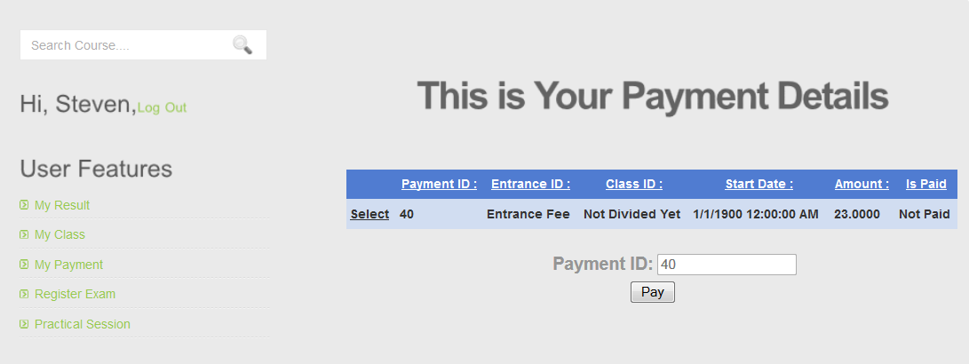

**-**To pay a payment, Click on **My Payment** link

-Select an **Unpaid** Payment 🡪**Pay**

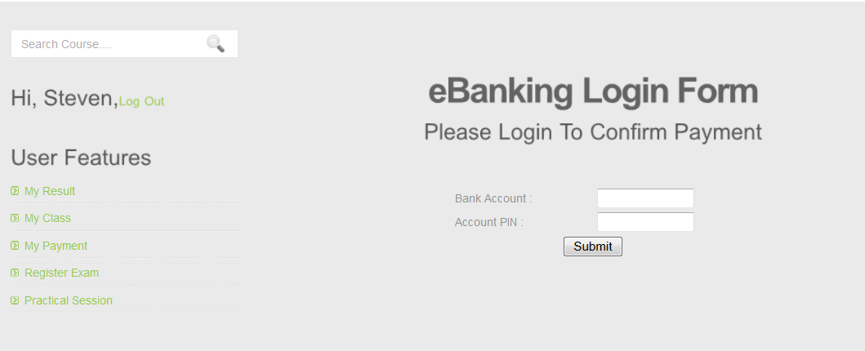

**-** In **eBanking Form**, Input Bank Account and PIN to accept a payment.

-Click On Submit

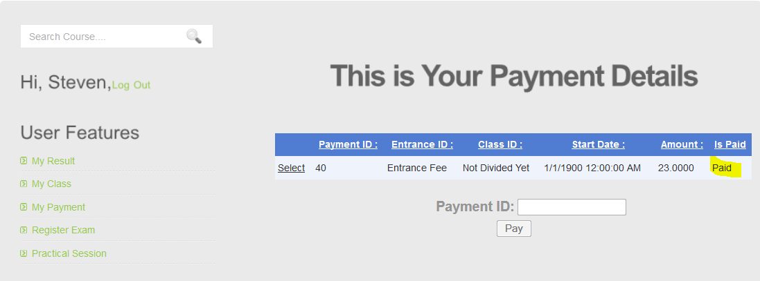

-A successful Payment will result to this

**NOTE : Please make sure that webservice is running while making payment.**

**4. CONFIRM A CLASS DIVISION**

**-**After taking an exam separately, the result will be updated by admin as soon as possible manually.

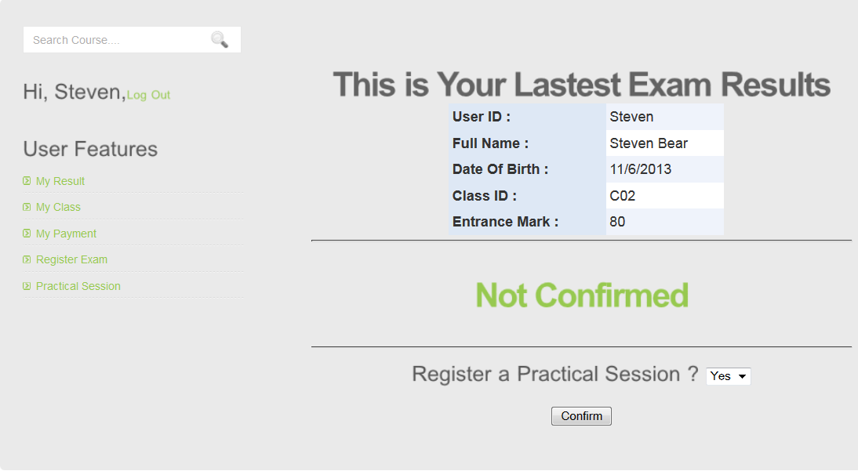

-After the result is out, user need to confirm a class then make a payment to have a place in class.

-In this section, user can choose to register for a practical session with a price of 1000$ or can register for it separately with a price of 1500$ later.

-Click Confirm then go to **My Payment** section to make necessary payment.

**5. GET A CLASS INFO**

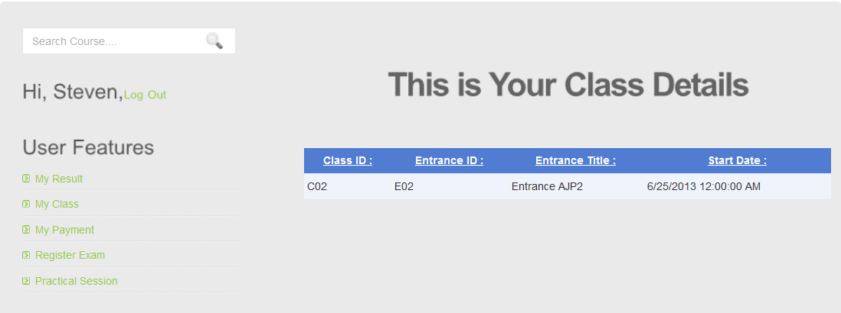

**-**After making necessary payments, a class information will be available for user **in My Class** section

**6. PRACTICAL SESSION REGISTRATION**

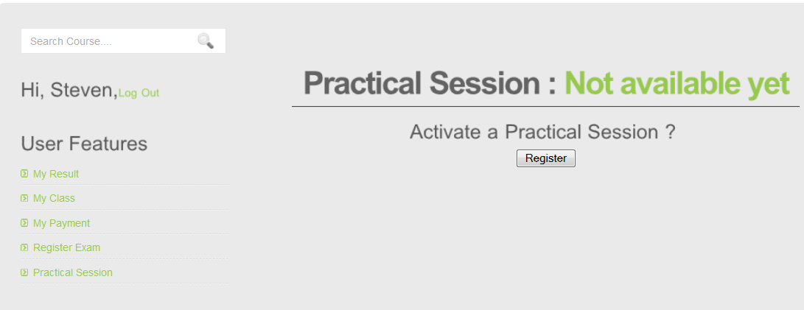

**-**If not registered along with class confirmation a practical session can also be registered separately thought Practical Session with price of 1500$

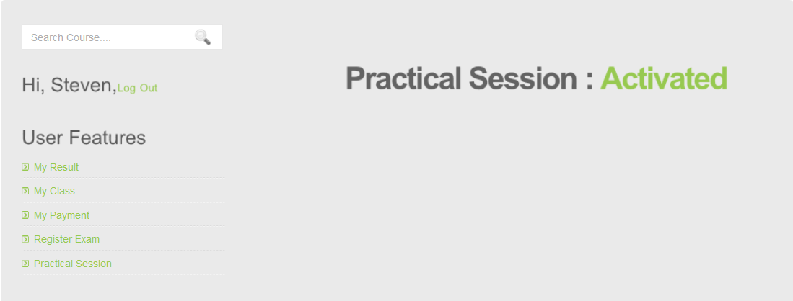

- After making necessary payments, we’ll have this screen in Practical Session Section

1. **Admin Guide**

* You must login with username “**admin**” and password “**12345678**”.

1. **MANAGE COURSE**

-The list and information of Course or you can search course Insert information into textbox, after click button “Search”

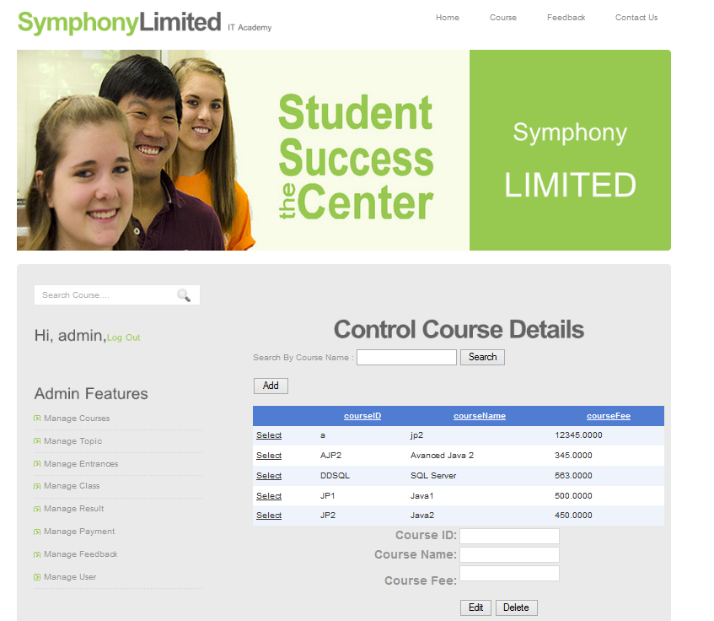

-To add new Course, click button “Add”. After input information Course ID, Course Fee, Course Name not null, click button “Add” insert to database and click button “Reset” to reset.

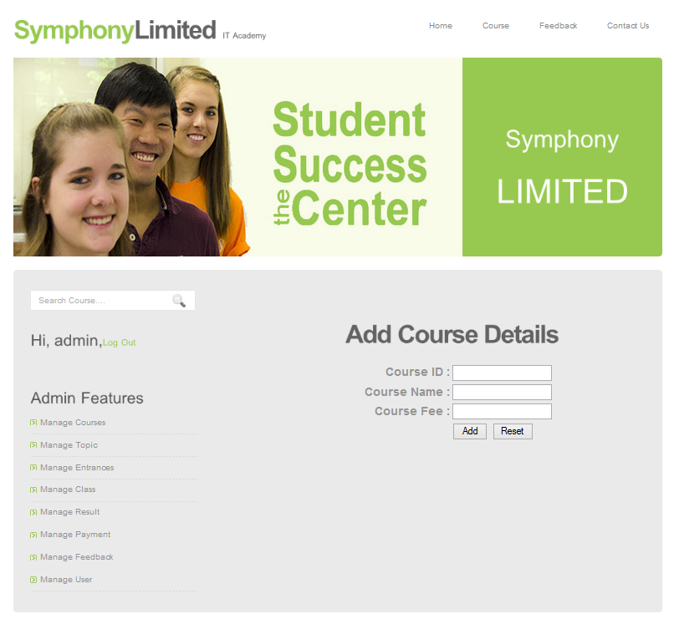

- To edit course, choice “Select” button then choice “Edit” button.

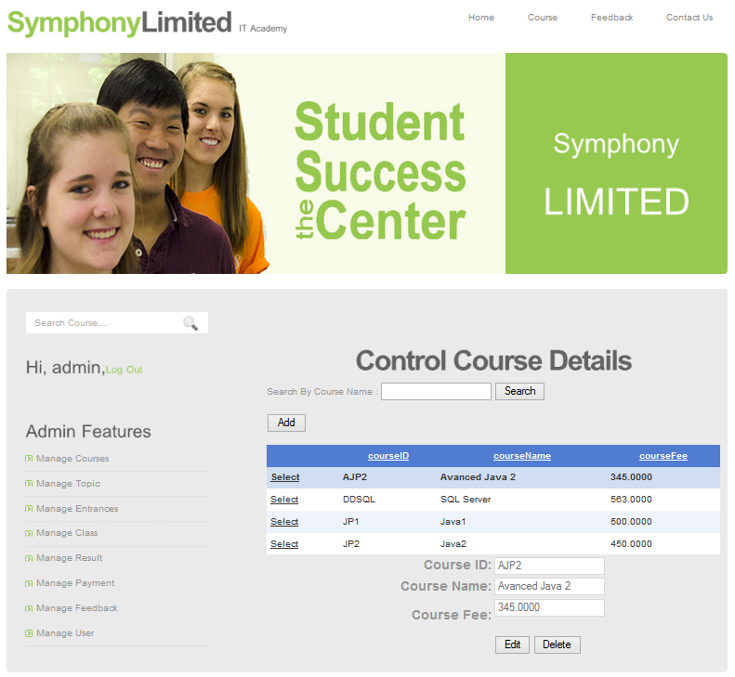

- After edit information, click “Update” to update to database and click “Cancel” to cancel.

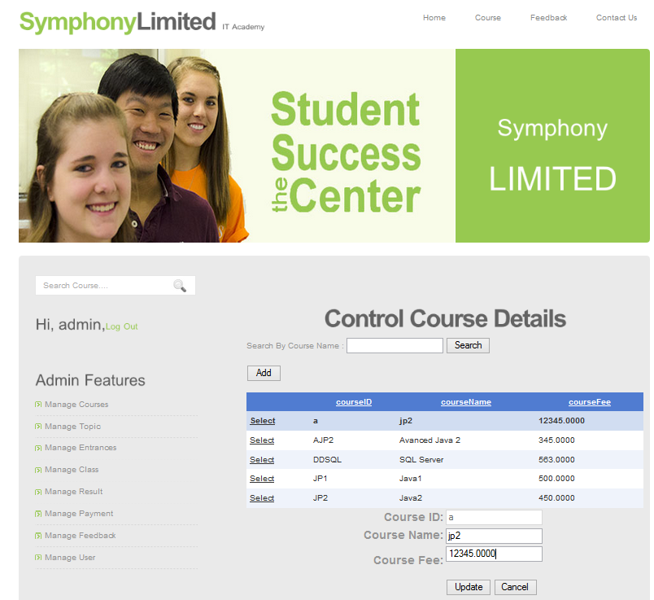

- To delete course, choice “Select” button then choice “Delete” button.

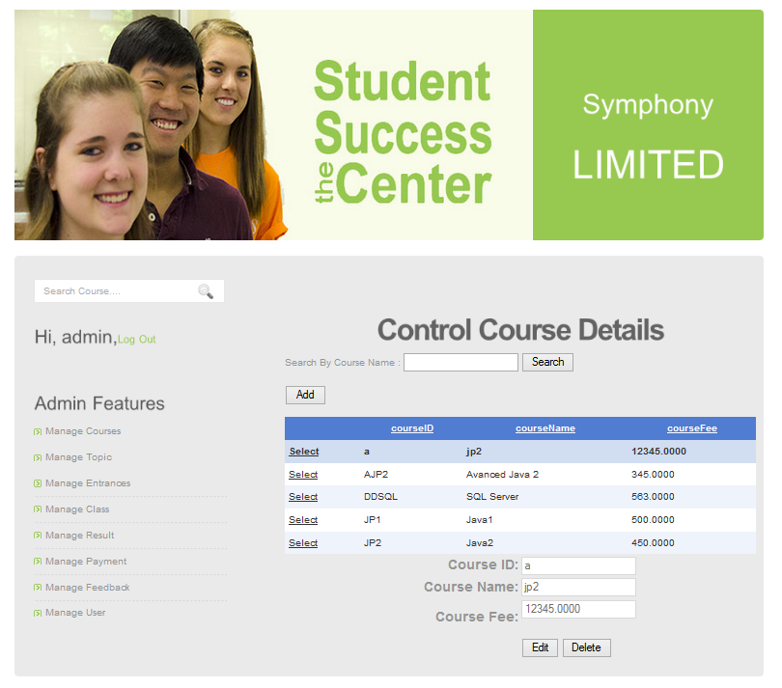

-After choice “Delete” button click “Remove” to remove from database, click “Cancel” to cancel.

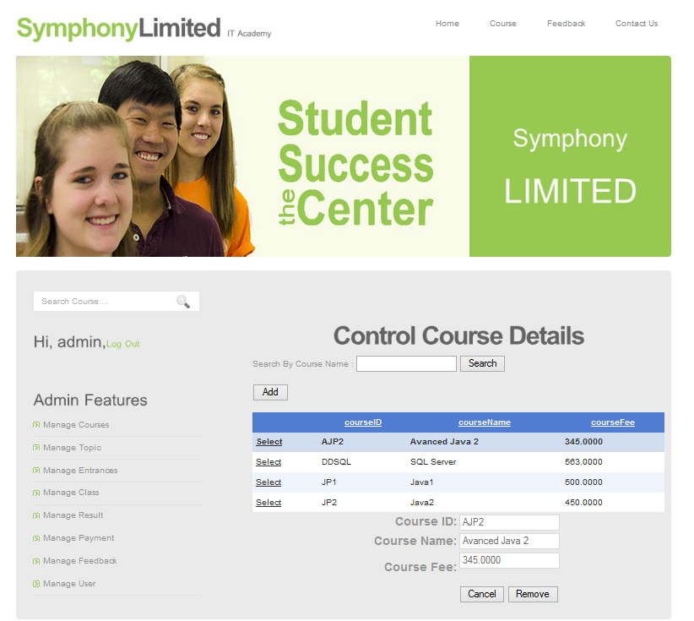

1. **MANAGE TOPIC**

-The list and information of Topic or can search topic Insert information into textbox, after click button “Search”

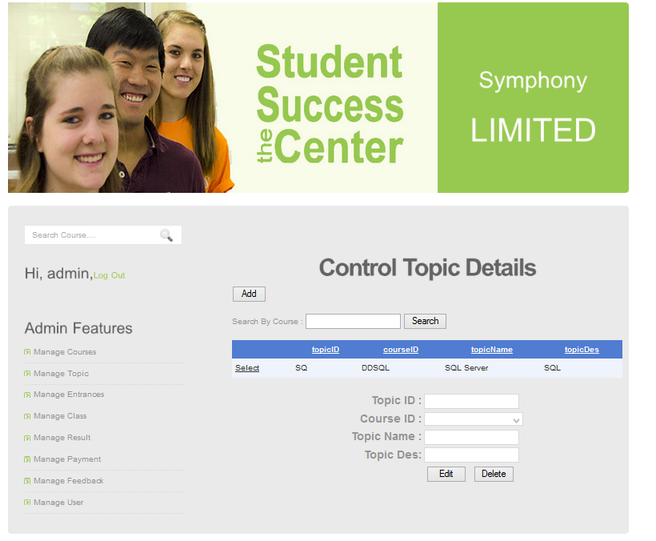

-To add new Topic, click button “Add”. After input information TopicID, Topic Des, Topic Name not null, click button “Add” insert to database and click button “Reset” to reset.

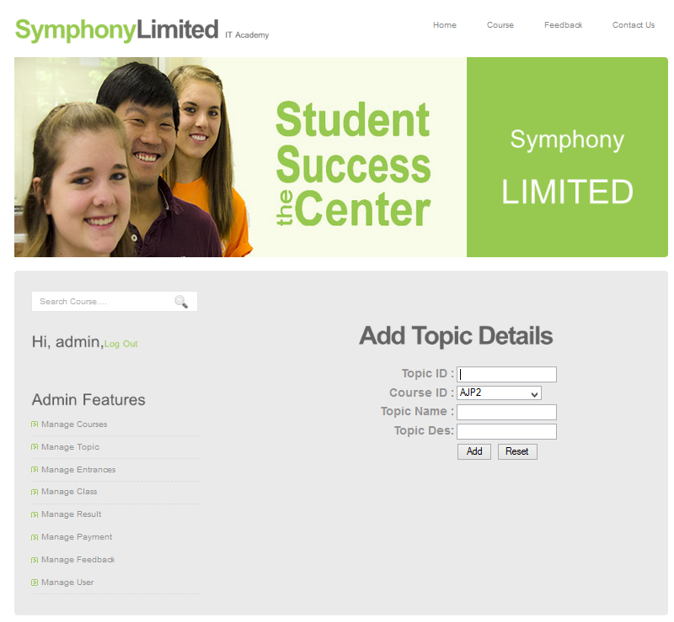

- To edit Topic, choice “Select” button then choice “Edit” button.

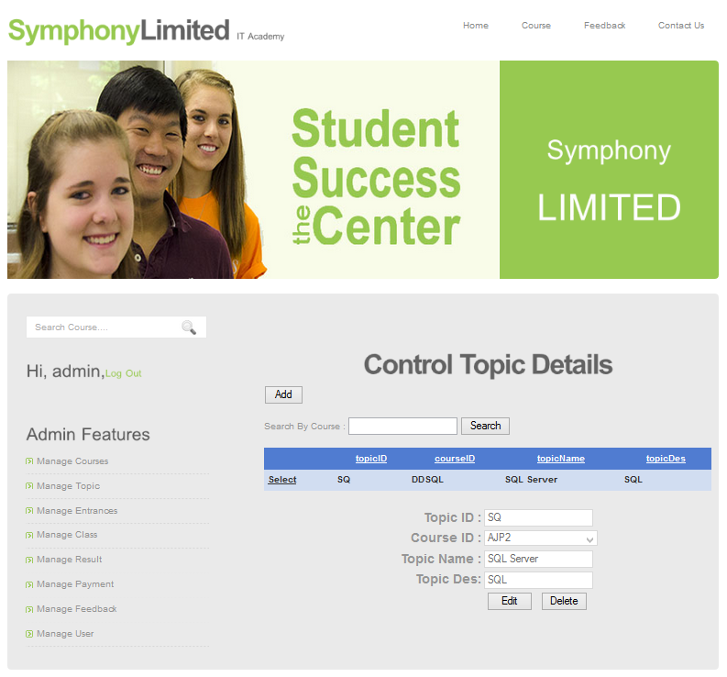

. After edit information, click “Update” to update to database and click

“Cancel” to cancel.

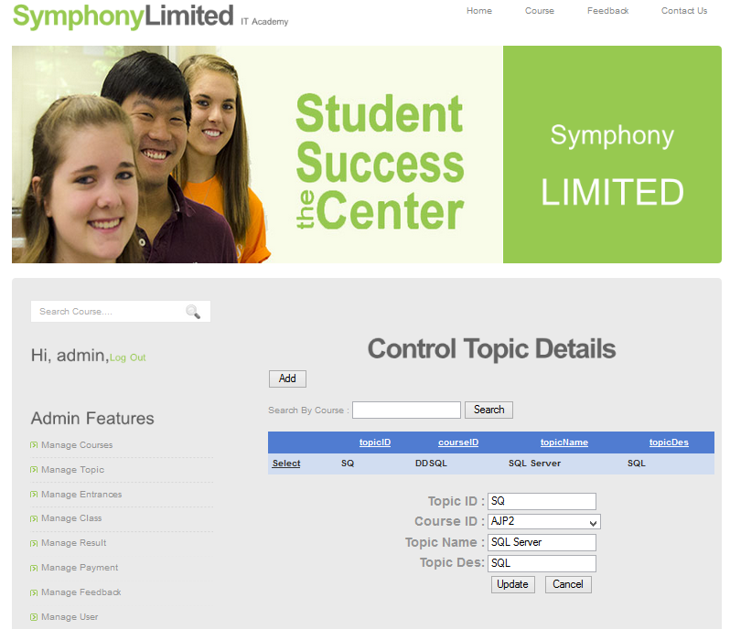

- To delete course, choice “Select” button then choice “Delete” button.

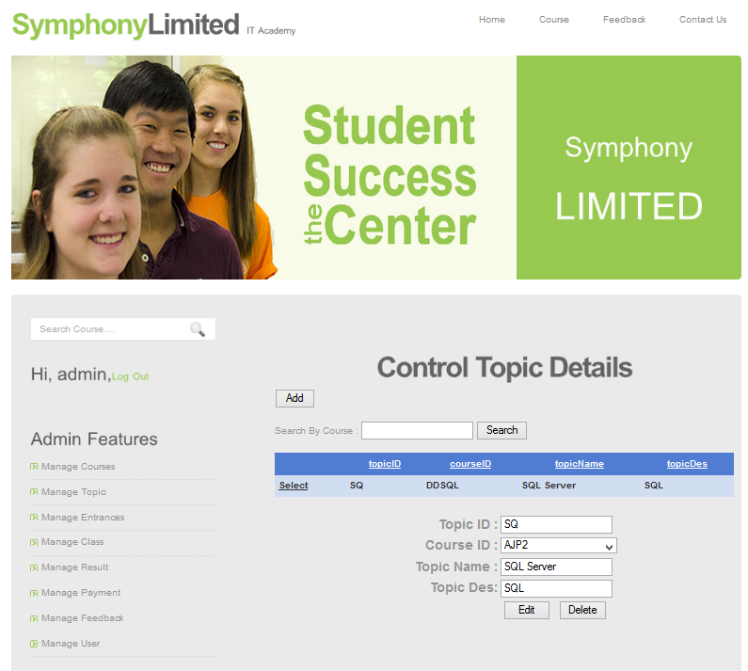

-After choice “Delete” button click “Remove” to remove from database, click “Cancel” to cancel.

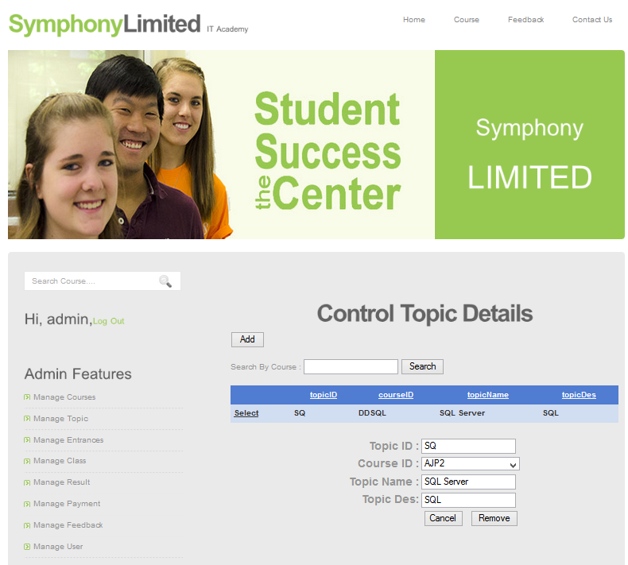

1. **MANAGE ENTRANCE**

-The list and information of Entrance or you can search entrance Insert information into textbox, after click button “Search”.

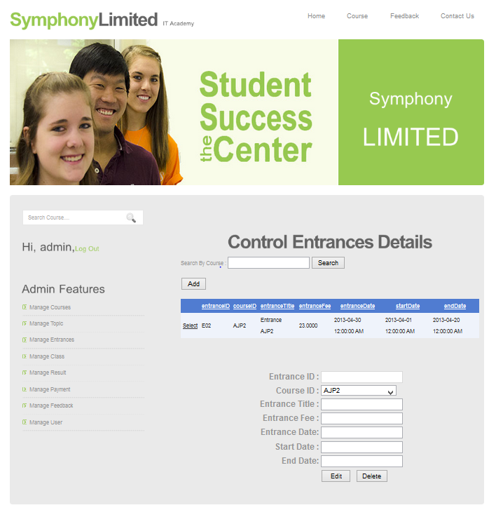

-To add new Entrance, click button “Add”. After input information to textbox click button “Add” insert to database and click button “Reset” to reset.

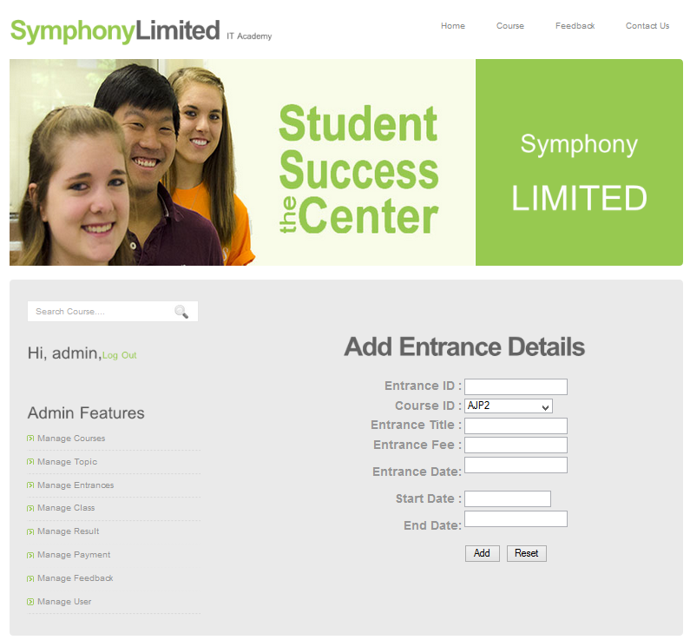

- To edit course, choice “Select” button then choice “Edit” button. 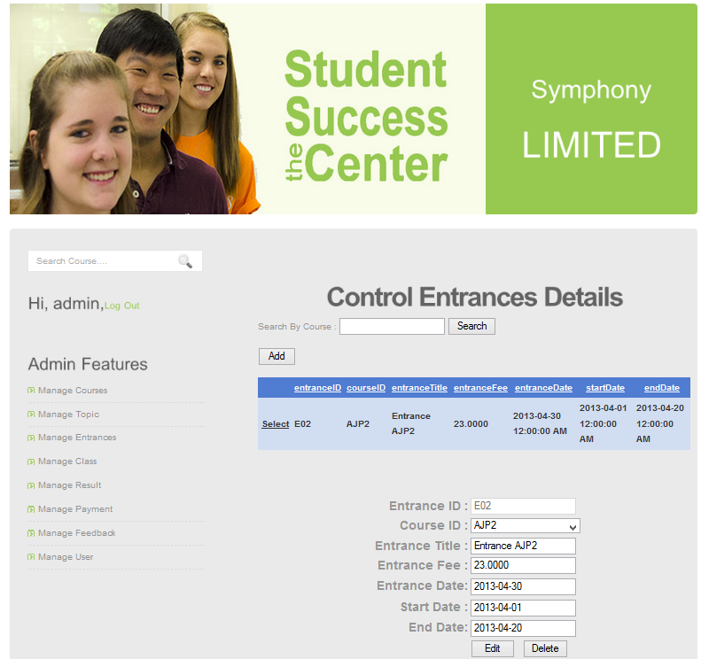

-After edit information, click “Update” to update to database and click

“Cancel” to cancel.

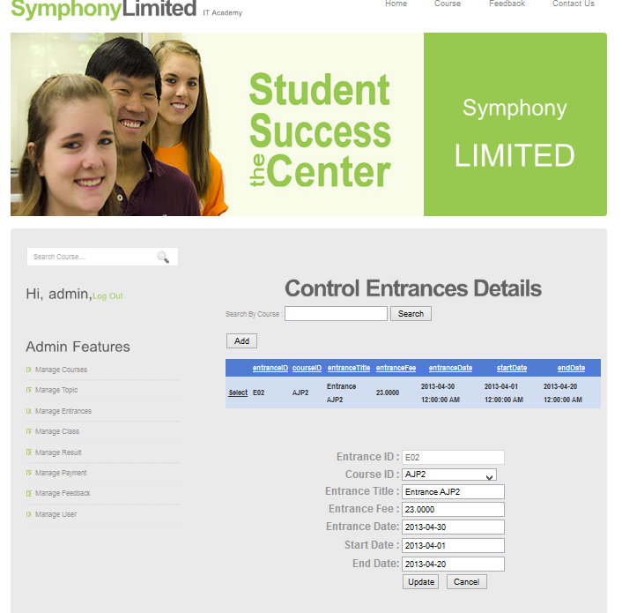

- To delete course, choice “Select” button then choice “Delete” button.

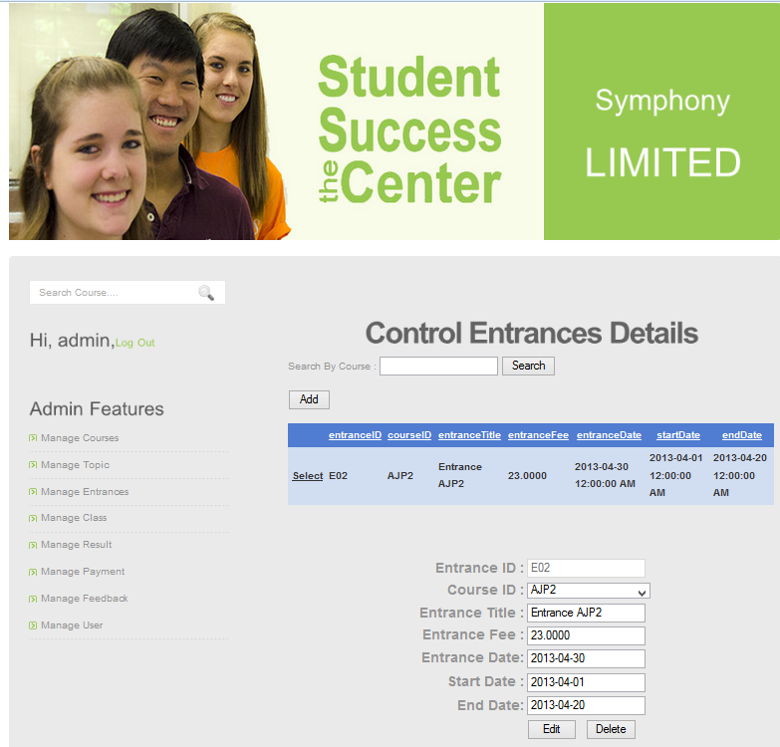

-After choice “Delete” button click “Remove” to remove from database, click “Cancel” to cancel.

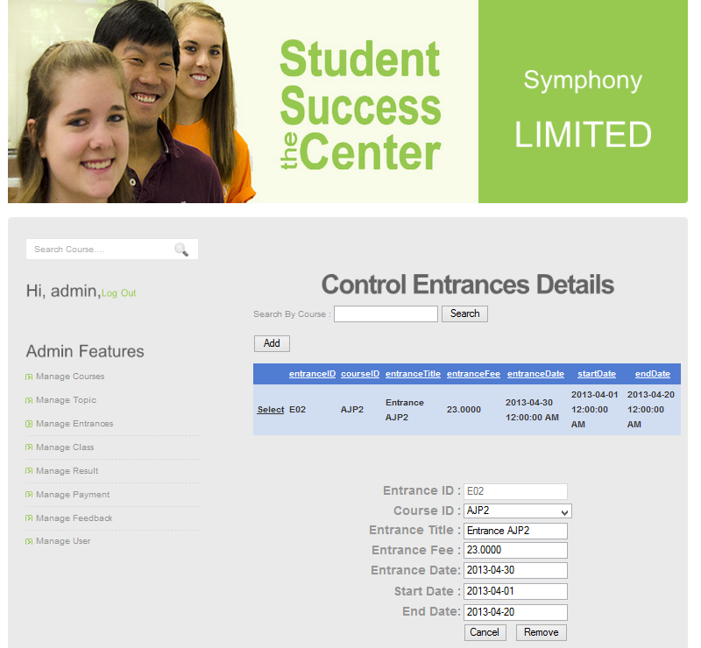

1. **MANAGE CLASS**

-The list and information of Class or you can search class Insert information into textbox, after click button “Search”

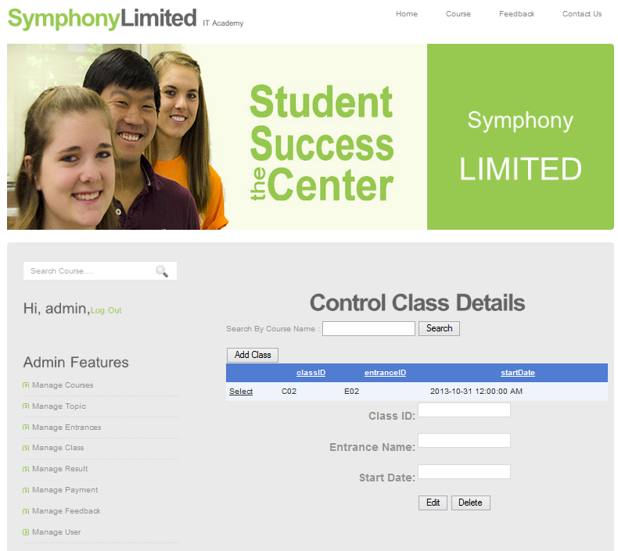

**Note: To One Entrance You Can Only Add One Class**

-To add new Class, click button “Add Class”. After input information Class ID, Start Date not null, click button “Add” insert to database and click button “Reset” to reset.

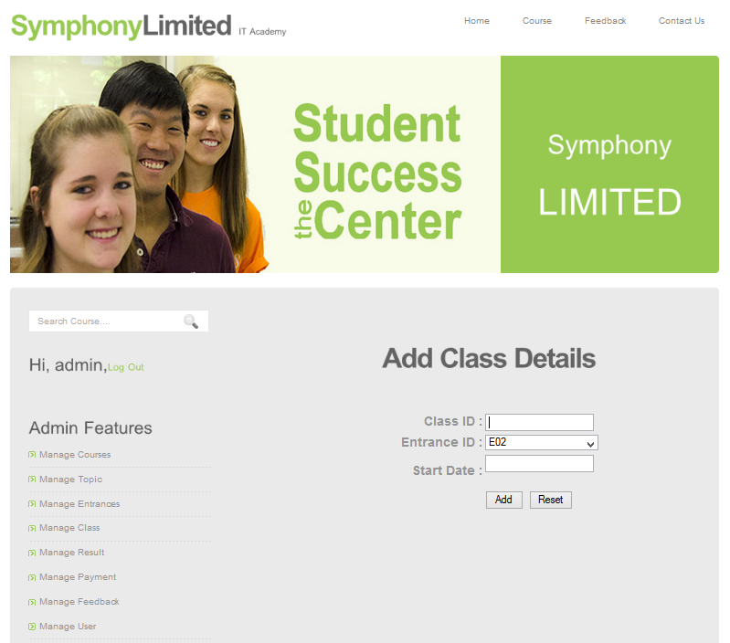

- To edit Class, choice “Select” button then choice “Edit” button.

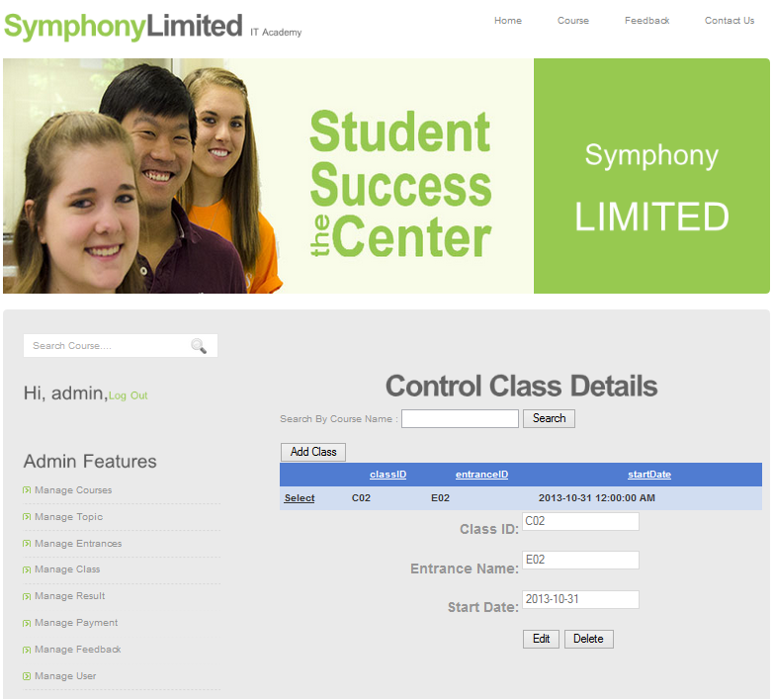

-After edit information, click “Update” to update to database and click

“Cancel” to cancel.

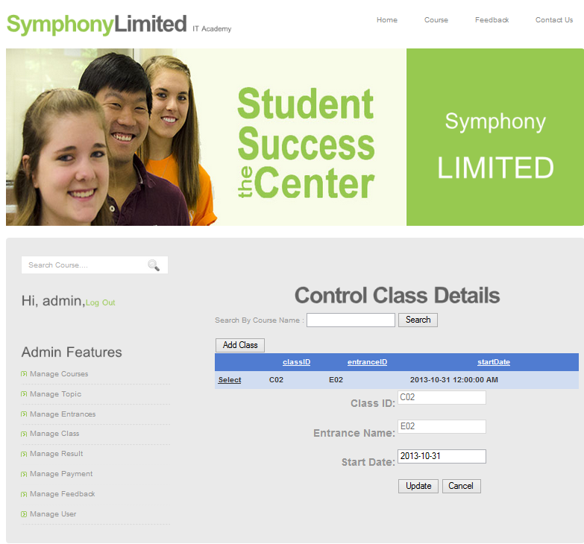

- To delete course, choice “Select” button then choice “Delete” button.

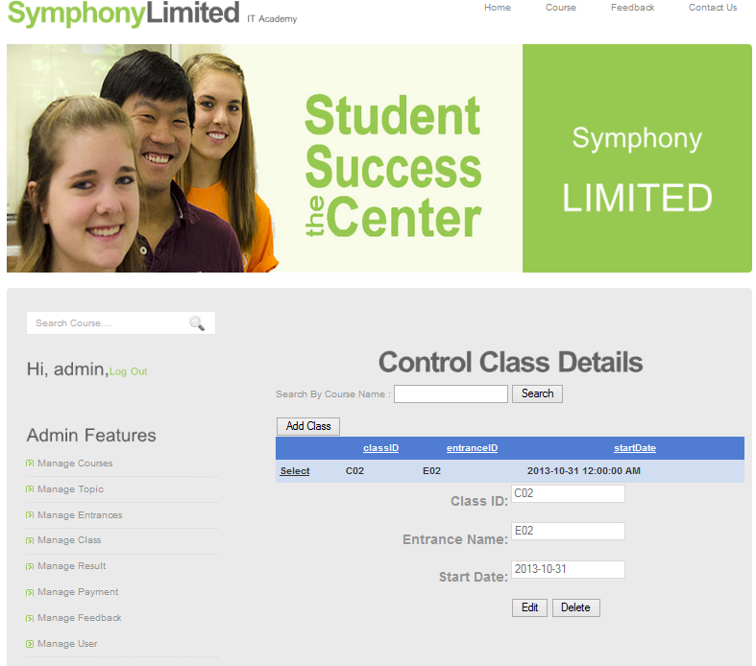

-After choice “Delete” button click “Remove” to remove from database, click “Cancel” to cancel.

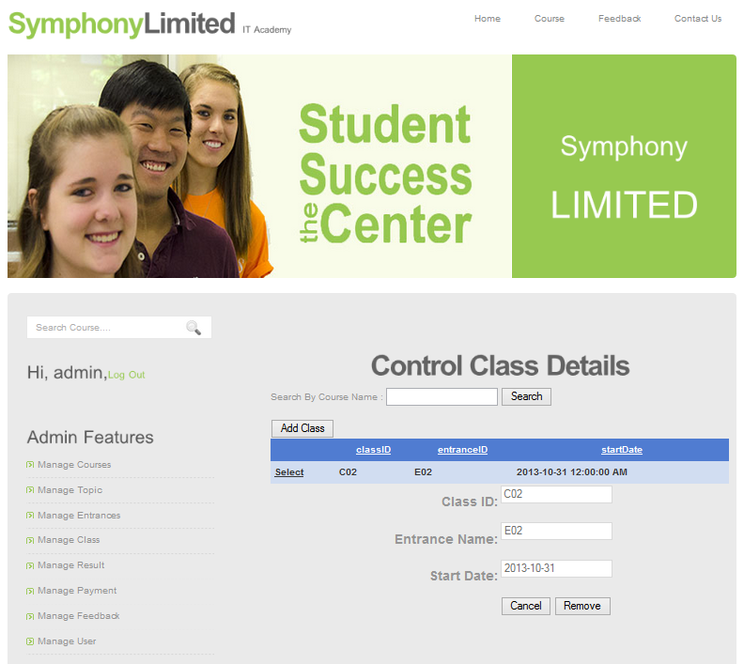

1. **MANAGE RESULT**

-The list and information of Result or you can search result by username insert information into textbox, after click button “Search”

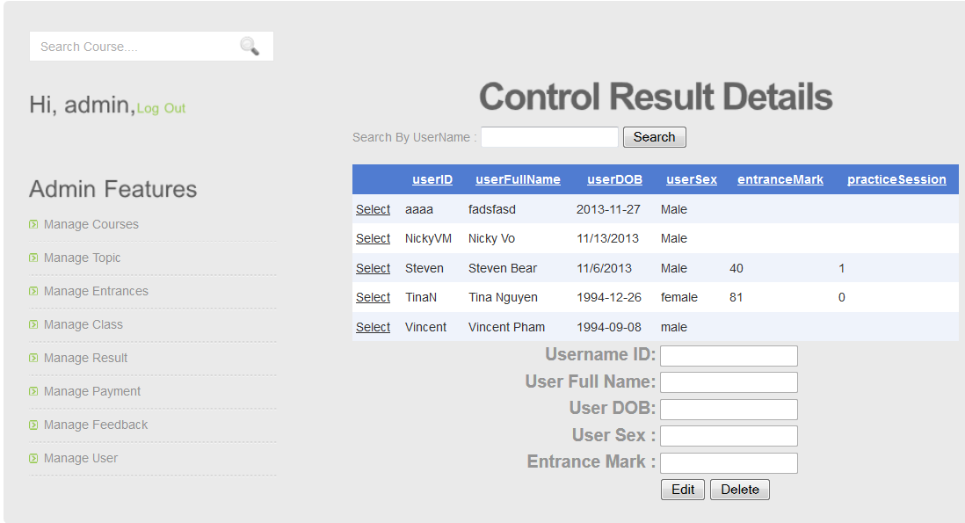

- To edit result, choice “Select” button then choice “Edit” button. 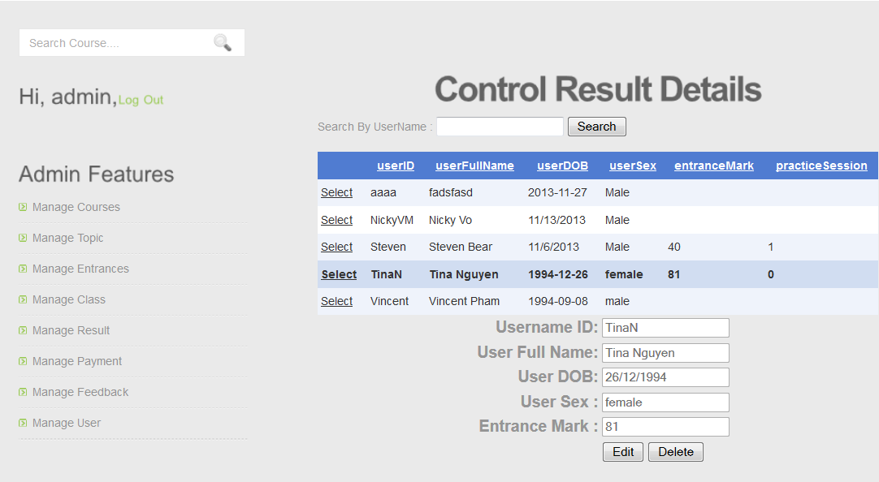

After edit information, click “Update” to update to database and click “Cancel” to cancel. 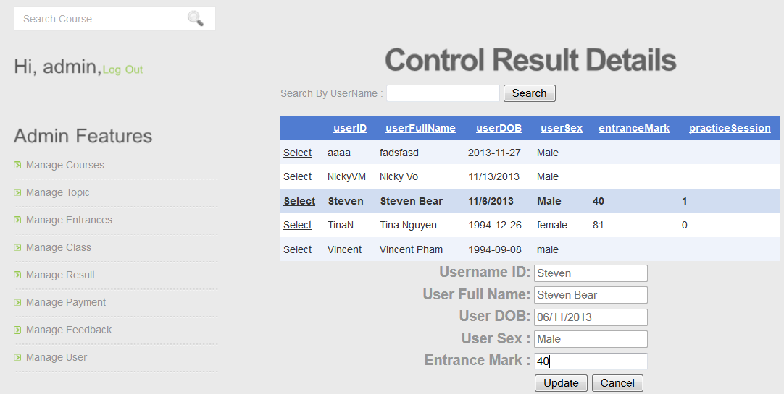

- To delete course, choice “Select” button then choice “Delete” button.

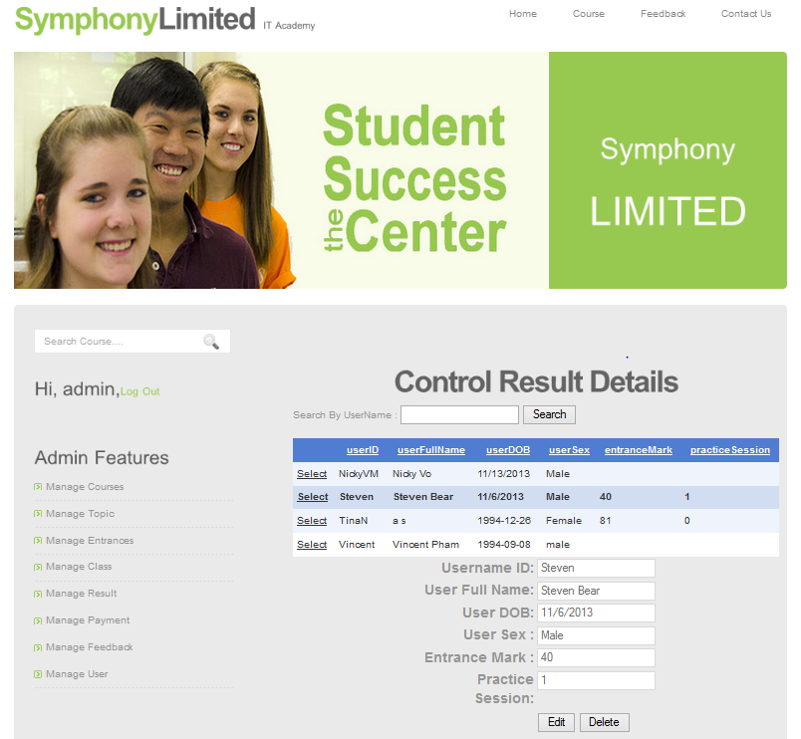

-After choice “Delete” button click “Remove” to remove from database, click “Cancel” to cancel.

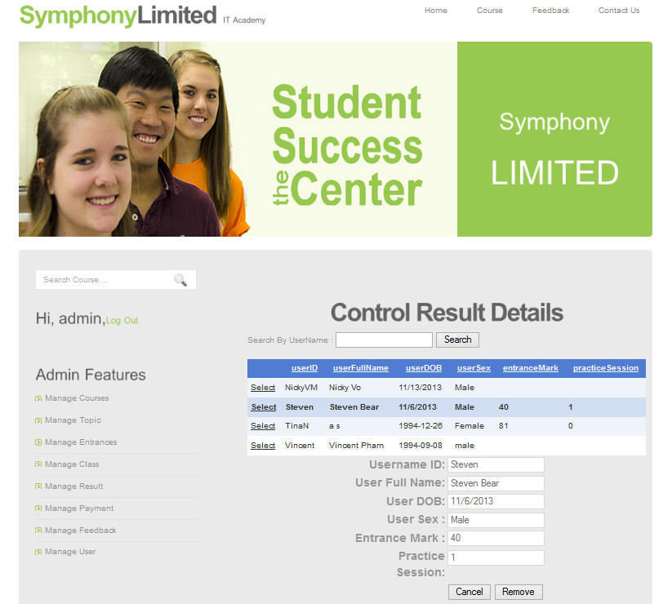

1. **MANAGER PAYMENT**

-The list and information Payment of user or you can search payment by username insert information into textbox, after click button “Search”

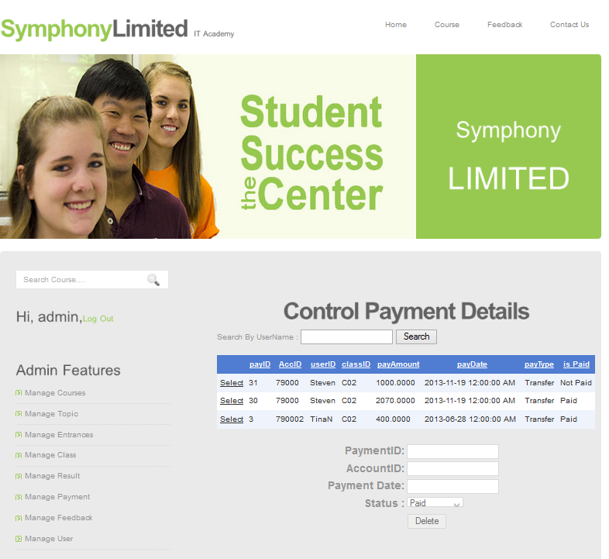

- To delete payment, choice “Select” button then choice “Delete” button.

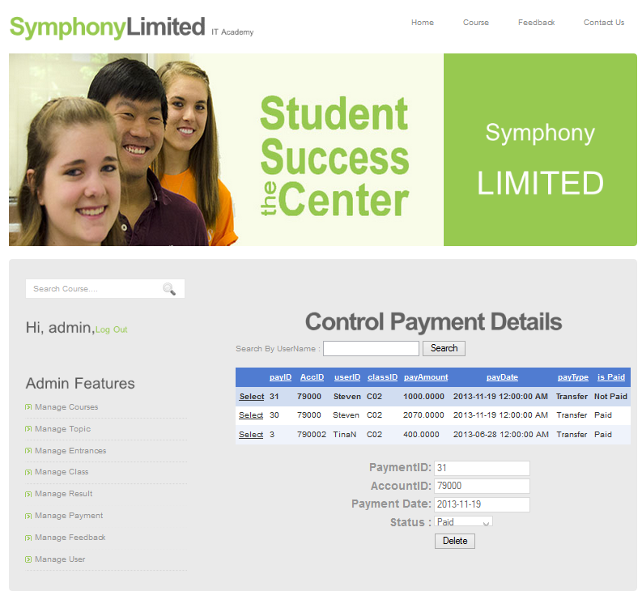

-After choice “Delete” button click “Remove” to remove from database

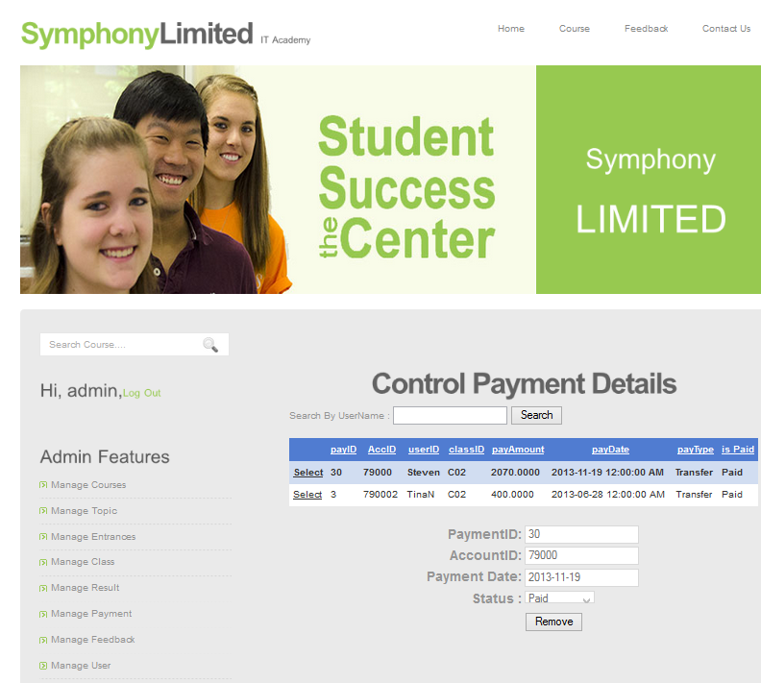

1. **MANAGE FEEDBACK**

-The list and information of feedback or can search feedback insert information into textbox, after click button “Search”

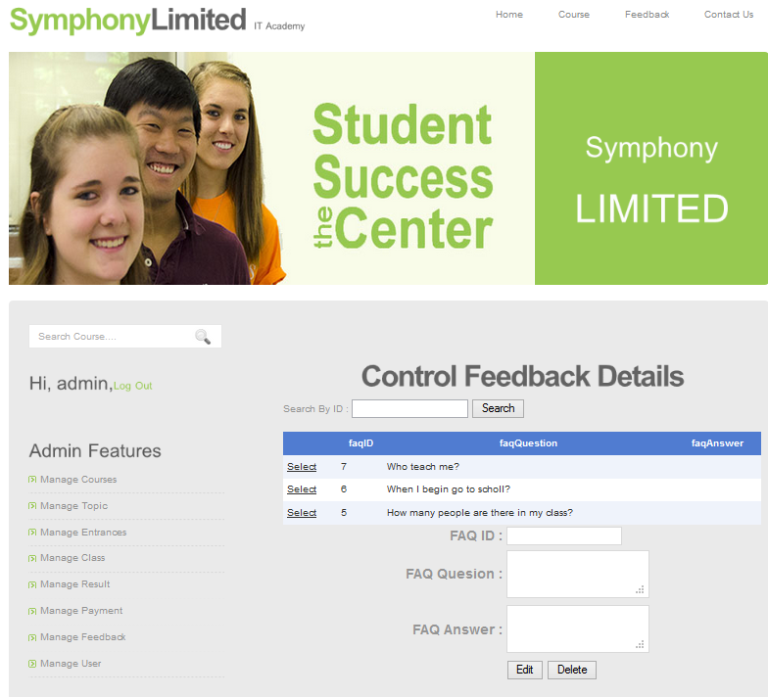

- To answer a feedback, choice “Select” button then choice “Edit” button.

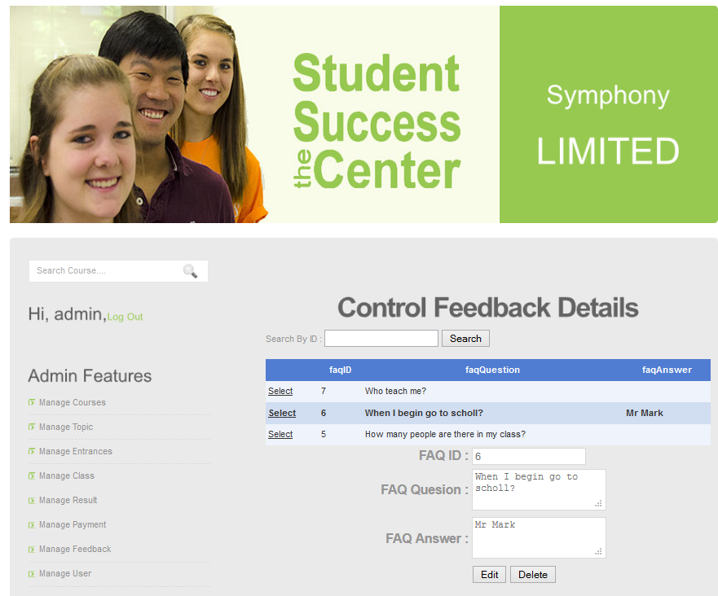

-After edit information, click “Update” to update to database and click

“Cancel” to cancel.

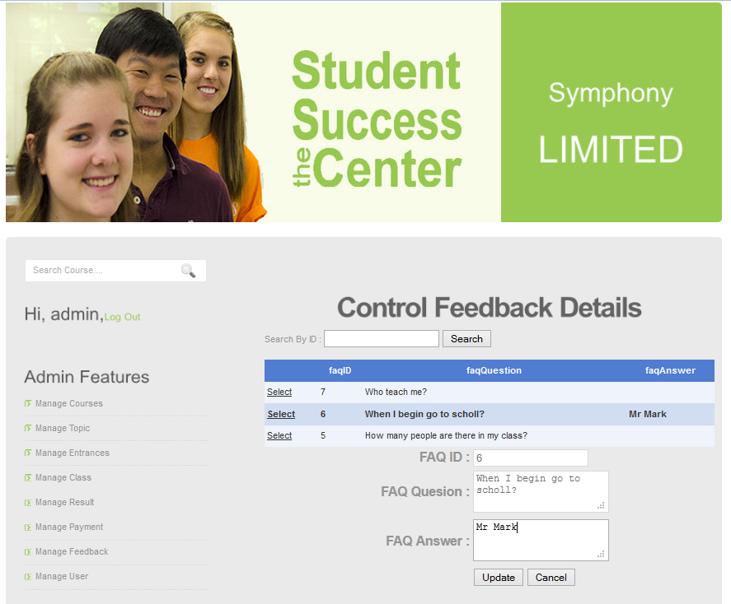

- To delete a feedback, choice “Select” button then choice “Delete” button.

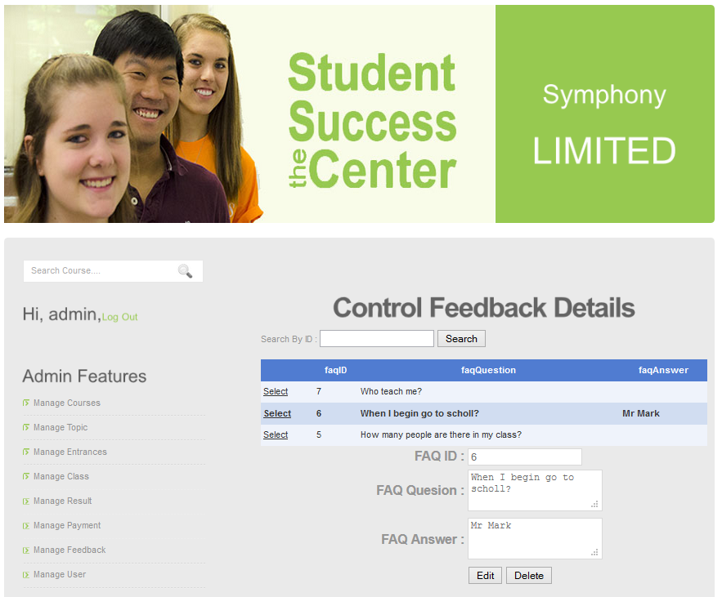

-After choice “Delete” button click “Remove” to remove from database, click “Cancel” to cancel.

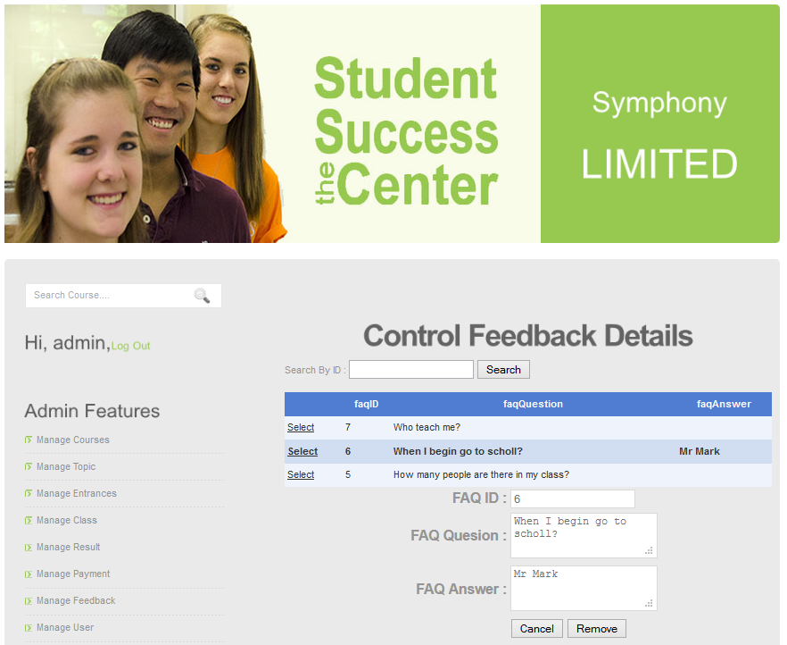

1. **MANAGER USER**

-The list and information of user, search user by username insert information into textbox, after click button “Search”

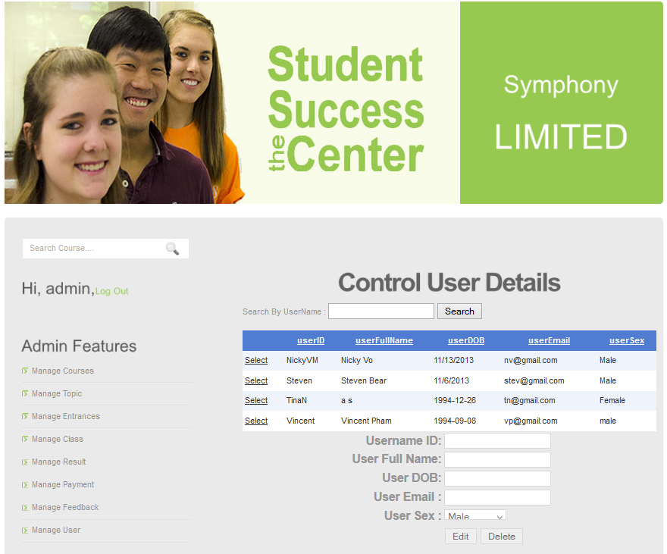

- To edit user, choice “Select” button then choice “Edit” button.

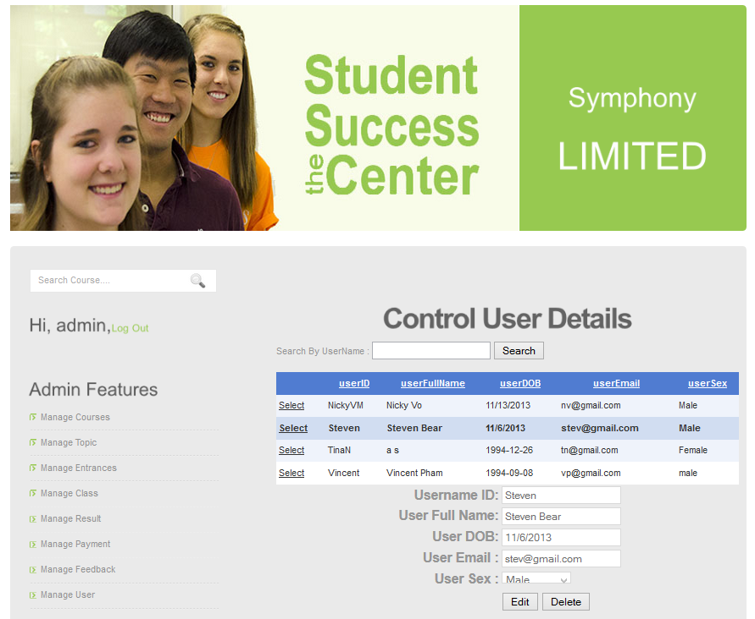

-After edit information, click “Update” to update to database and click

“Cancel” to cancel.

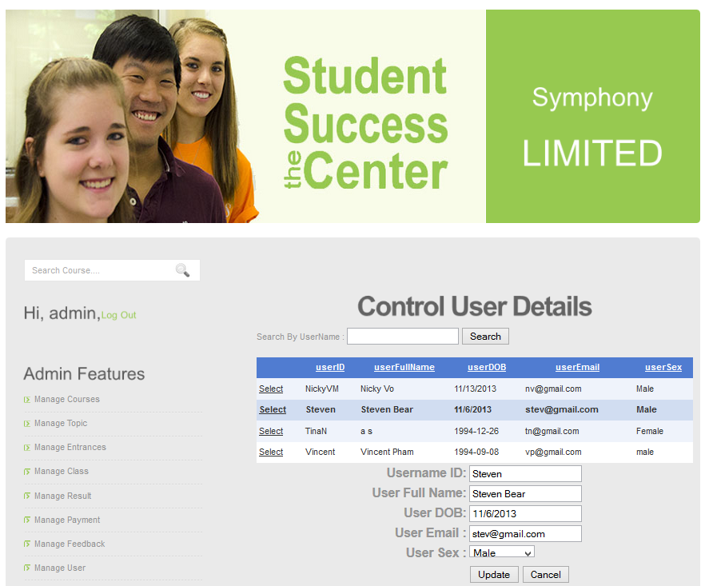

- To delete user, choice “Select” button then choice “Delete” button.



-After choice “Delete” button click “Remove” to remove from database, click “Cancel” to cancel.

